

SIMATS ENGINEERING

Saveetha Institute of Medical and Technical Sciences
Chennai-602105

September 2026

CSA0613– Design and Analysis of Algorithms

Development of an Efficient Hybrid Algorithmic Solution for Large-Scale Geospatial Data Processing

Assignment Report

Submitted by

ARCHANA DEVI.P (192521192)
NIVASINI. V.M (192511356)
SAFYA.B(192411043)

Assignment Information

Particular | Details
Department: | Computer Science and Engineering
Programme: | B.E./B.Tech. Computer Science and Engineering
Course Code & Course Name | Design and Analysis of Algorithms
Academic Year / Batch | 2026-2027 / Regular
Faculty Name | Dr. F. Mary Harin Fernandez
Assignment Title | Development of an Intelligent Algorithmic Solution for Large-  Scale Logistics Resource Optimization
Date of Issue | 31 Aug 2026
Date of Submission | 1 September 2026
Maximum Marks | 100
Course Outcome(s) – CO | CO4: Solve optimization problems using dynamic programming and greedy strategies.
Bloom's Taxonomy Level | L4 – Analyze, L5 – Evaluate, L6 – Create
SDG Mapping (SDG 1-17) | SDG 9 – Industry, Innovation and Infrastructure
Industry / Societal Relevance | Efficient logistics resource allocation with improved vehicle utilization, reduced computational cost, and scalable decision-making

Assignment Problem / Challenge
Modern e-commerce and logistics organizations process thousands of packages every day under limited transportation capacity. Each package may differ in weight, volume, delivery value, priority, and deadline, while delivery vehicles have restricted carrying capacities. Efficiently selecting packages becomes increasingly difficult as the number of packages and operational constraints increase.
Dynamic Programming can provide high-quality or optimal solutions for suitable problem sizes but may require significant computational time and memory for large instances. Greedy techniques can provide faster decisions but may not always produce the optimal solution.
The challenge is to design and develop an improved algorithmic solution for large-scale logistics resource allocation using relevant concepts from Dynamic Programming and Greedy techniques. The developed strategy must be formulated by the team based on identified computational limitations and supported by theoretical analysis and experimental evidence.

Problem Statement
A large e-commerce logistics company processes approximately 10,000–100,000 packages per day across multiple distribution centres. Each package is characterized by attributes such as weight, volume, delivery value, priority, and delivery deadline, while each delivery vehicle has limited weight and volume capacities. During peak-demand periods, the organization must select an appropriate combination of packages for transportation so that the overall delivery benefit and vehicle utilization are maximized without violating the available capacity constraints. Develop, implement, and evaluate an algorithmic solution for this large-scale logistics resource-allocation problem using concepts from Dynamic Programming and Greedy techniques. Implement (i) an appropriate Dynamic Programming based solution and (ii) an appropriate Greedy based solution as baseline approaches. Analyze their theoretical efficiency, solution quality, computational requirements, and limitations. Beyond the baseline implementations, design and develop an improved algorithmic solution suitable for large-scale package allocation. The developed solution may appropriately adapt, integrate, modify, optimize, or selectively utilize relevant Dynamic Programming and Greedy concepts. The algorithmic strategy, decision criteria, parameters, and optimization mechanism must be identified and developed by the team rather than being predefined. Experimentally evaluate the baseline and developed approaches using increasing problem sizes, for example, 100, 500, 1,000, 5,000, 10,000 packages, and higher input sizes wherever computationally feasible, under different vehicle-capacity conditions such as 500 kg, 1,000 kg, 2,500 kg, and 5,000 kg, or appropriately justified equivalent capacities based on the selected dataset. Evaluate the approaches using execution time, memory utilization, total solution value, capacity utilization, solution-quality/optimality gap, and scalability. Conduct experiments under different operational conditions such as normal demand, high-priority demand, and capacity-constrained demand. Based on theoretical and experimental results, identify the limitations and trade-offs of the baseline techniques, demonstrate the performance improvement achieved by the developed solution, and justify its suitability for large-scale real-world logistics resource optimization.
Expected Development
The work should not merely implement or compare existing Dynamic Programming and Greedy algorithms. The solution should demonstrate algorithmic development through:

- Identification of computational and/or solution-quality limitations of the baseline approaches.
- Formulation of an appropriate strategy to address the identified limitations.
- Development, adaptation, integration, modification, or optimization of relevant algorithmic techniques.
- Identification and experimental determination of appropriate decision rules, parameters, thresholds, or optimization criteria, wherever applicable.
- Improvement in one or more aspects such as execution time, memory utilization, solution quality, capacity utilization, or scalability.
- Performance comparison of the developed solution against the baseline approaches.
- Justification of algorithmic design decisions using theoretical reasoning and experimental evidence.

Requirements and Constraints

The following requirements and constraints shall be considered:

- Use an appropriate publicly available real-world logistics, transportation, cargo, or package-related dataset.
- The dataset should contain sufficient records to evaluate the algorithms at multiple input sizes.
- Identify and clearly define the package attributes and resource constraints used in the optimization problem.
- Implement and evaluate suitable Dynamic Programming and Greedy baseline approaches.
- Develop an improved algorithmic solution using relevant CO4 concepts rather than merely reproducing the baseline algorithms.
- The developed strategy must be designed and justified by the team.
- Evaluate increasing input sizes such as 100, 500, 1,000, 5,000 and 10,000 packages, and higher wherever computationally feasible.
- Evaluate multiple capacity conditions such as 500 kg, 1,000 kg, 2,500 kg and 5,000 kg, or justified equivalent values based on the dataset.
- Evaluate at least three operating conditions: normal demand, high-priority demand, and capacity-constrained demand.
- Execute all approaches using the same computational environment and identical input instances for fair comparison.
- Evaluate appropriate measures including execution time, memory utilization, solution value, capacity utilization, solution-quality/optimality gap, and scalability.
- Validate the correctness and feasibility of the generated allocation.
- Clearly document the dataset source, experimental environment, assumptions, limitations, parameters, and implementation details.

Student Work

1. Problem Understanding and Formulation

1.1 Understanding the Problem

In a real logistics company, deciding which packages should be loaded onto a vehicle is not as simple as selecting the most expensive packages first. A package may have a high delivery value but also occupy too much weight or space. Another package may have lower value but be very small and allow several other valuable packages to be transported together.

Therefore, the actual decision is a balance between benefit and available resources.

In this project, each package is treated as an item with several characteristics, such as:

Weight

Delivery value

Priority

Volume or resource requirement

Delivery urgency or deadline

The vehicle has limited transportation resources. Therefore, not every available package can be selected. The aim is to choose a combination of packages that provides the highest possible delivery benefit while respecting the available capacity.

This problem is important in real-world logistics because poor package allocation can result in underutilized vehicles, unnecessary transportation costs, delayed priority deliveries, and inefficient decision-making. As the number of packages increases, manually finding a good combination becomes practically impossible. An algorithmic solution is therefore required.

1.2 Dataset Selection and Description

For this study, a publicly available logistics dataset is selected as the basis for the experimental data. A suitable choice is the Delivery Logistics Dataset (India – Multi-Partner), which contains 25,000 delivery records and includes package and operational information such as package weight, delivery mode, vehicle type, distance, cost, and delivery outcomes.

The dataset is appropriate for this assignment because it contains enough records to test the algorithms using multiple input sizes. It also represents realistic logistics conditions more closely than a small artificial dataset.

The main attributes used or derived for this optimization experiment are:
Attribute | Role in the Algorithm
Package ID | Identifies each package
Package Weight | Consumes vehicle capacity
Package Value | Represents delivery benefit
Priority | Represents the importance of the delivery
Delivery Mode | Helps identify urgent or faster deliveries
Distance | Can be used as an operational factor
Delivery Cost | Can contribute to the value calculation

Where an attribute such as package value or priority is not directly available in the required format, it will be derived through a clearly documented transformation rule based on the dataset attributes.

1.3 Input

The algorithm receives:

Number of packages

Package ID

Weight of each package

Delivery value

Priority level

Optional deadline or urgency information

Vehicle weight capacity

Optional vehicle volume capacity

Algorithm parameters

1.4 Output

The algorithm produces:

List of selected packages

Number of packages selected

Total delivery value

Total weight used

Remaining vehicle capacity

Vehicle capacity utilization

Execution time

Memory usage

Solution-quality comparison

1.5 Optimization Objective

The main objective is to maximize the total benefit obtained from the selected packages.

Maximize Z=∑i=1nBixi\text{Maximize } Z = \sum_{i=1}^{n} B_i x_i

where:

BiB_i represents the benefit or adjusted delivery value of package ii

xi=1x_i = 1 if package ii is selected

xi=0x_i = 0 if package ii is not selected

Subject to the weight constraint:

∑i=1nWixi≤C\sum_{i=1}^{n} W_i x_i \leq C

where:

WiW_i = weight of package ii

CC = vehicle capacity

If volume is also considered:

∑i=1nVolixi≤VC\sum_{i=1}^{n} Vol_i x_i \leq V_C

1.6 Computational Challenges

The difficulty increases rapidly as the number of packages grows. A solution that works comfortably for 100 packages may become computationally expensive for 10,000 packages.

The major challenges are:

Large search space

Increasing execution time

High memory requirements for DP

Possible reduction in solution quality for Greedy methods

Maintaining fair performance under different capacity conditions

Handling priority packages without wasting vehicle capacity

The central challenge is therefore not simply finding the best solution. It is finding a good solution within a reasonable amount of time and memory.

1.7 Assumptions and Limitations

The following assumptions are used:

Each package is either fully selected or not selected.

Vehicle capacity is fixed during one experiment.

Package attributes are available before the allocation decision.

Each experiment uses the same input for all algorithms.

The package selection problem is simplified to focus on allocation rather than route planning.

Limitations include:

Real-time traffic conditions are not considered.

Multi-vehicle routing is outside the main scope.

Some attributes may be derived from available dataset fields.

Very large DP experiments may require capacity scaling because of memory limitations.

2. Application of Course Knowledge

This assignment applies the concepts of Dynamic Programming and Greedy strategies, which are directly related to CO4.

The important lesson from applying these techniques is that no single algorithm is automatically best in every situation. Dynamic Programming focuses on carefully exploring decisions, while Greedy techniques focus on making fast choices.

2.1 Dynamic Programming Approach

The package-selection problem can be represented as a variation of the 0/1 Knapsack problem.

Each package has two possible decisions:

Select it.

Do not select it.

Let:

DP[i][w]DP[i][w]

represent the maximum total delivery value obtained by considering the first ii packages with capacity ww.

The recurrence relation is:

DP[i][w]=max⁡(DP[i−1][w],Bi+DP[i−1][w−Wi])DP[i][w] = \max(DP[i-1][w], B_i + DP[i-1][w-W_i])

when package ii fits inside the available capacity.

Otherwise:

DP[i][w]=DP[i−1][w]DP[i][w] = DP[i-1][w]

The base condition is:

DP[0][w]=0DP[0][w] = 0

The final solution is constructed by tracing the decisions that produced the maximum value.

Complexity

For nn packages and capacity CC:

Time complexity: O(nC)O(nC)

Memory complexity: O(nC)O(nC) for the full table

Dynamic Programming is valuable because it gives a high-quality reference solution. However, the main limitation is that increasing capacity and input size can make the DP table expensive to construct and store.

2.2 Greedy Approach

The Greedy approach makes faster decisions by ranking packages using a selection score.

For this study, the score can be defined as:

Scorei=Valuei×PriorityiWeightiScore_i = \frac{Value_i \times Priority_i}{Weight_i}

This gives preference to packages that provide high value and priority while using less vehicle capacity.

The Greedy process is:

Calculate the score for every package.

Sort packages from highest to lowest score.

Select a package if it fits within the remaining capacity.

Continue until no more suitable packages can be added.

Complexity

The main operation is sorting:

Score calculation: O(n)O(n)

Sorting: O(nlog⁡n)O(n\log n)

Selection: O(n)O(n)

Overall complexity:

O(nlog⁡n)O(n\log n)

The Greedy algorithm is fast and scalable, but it can make a locally attractive decision that prevents a better overall combination from being selected.

2.3 Contribution to the Developed Solution

The two methods contribute different strengths:

DP teaches the value of combination-based decision-making.

Greedy teaches the importance of fast prioritization.

The proposed APS-Hybrid algorithm combines these ideas by allowing Greedy processing to reduce the problem size and DP processing to improve decisions in the most important part of the candidate set.

3. Solution / Design / Methodology

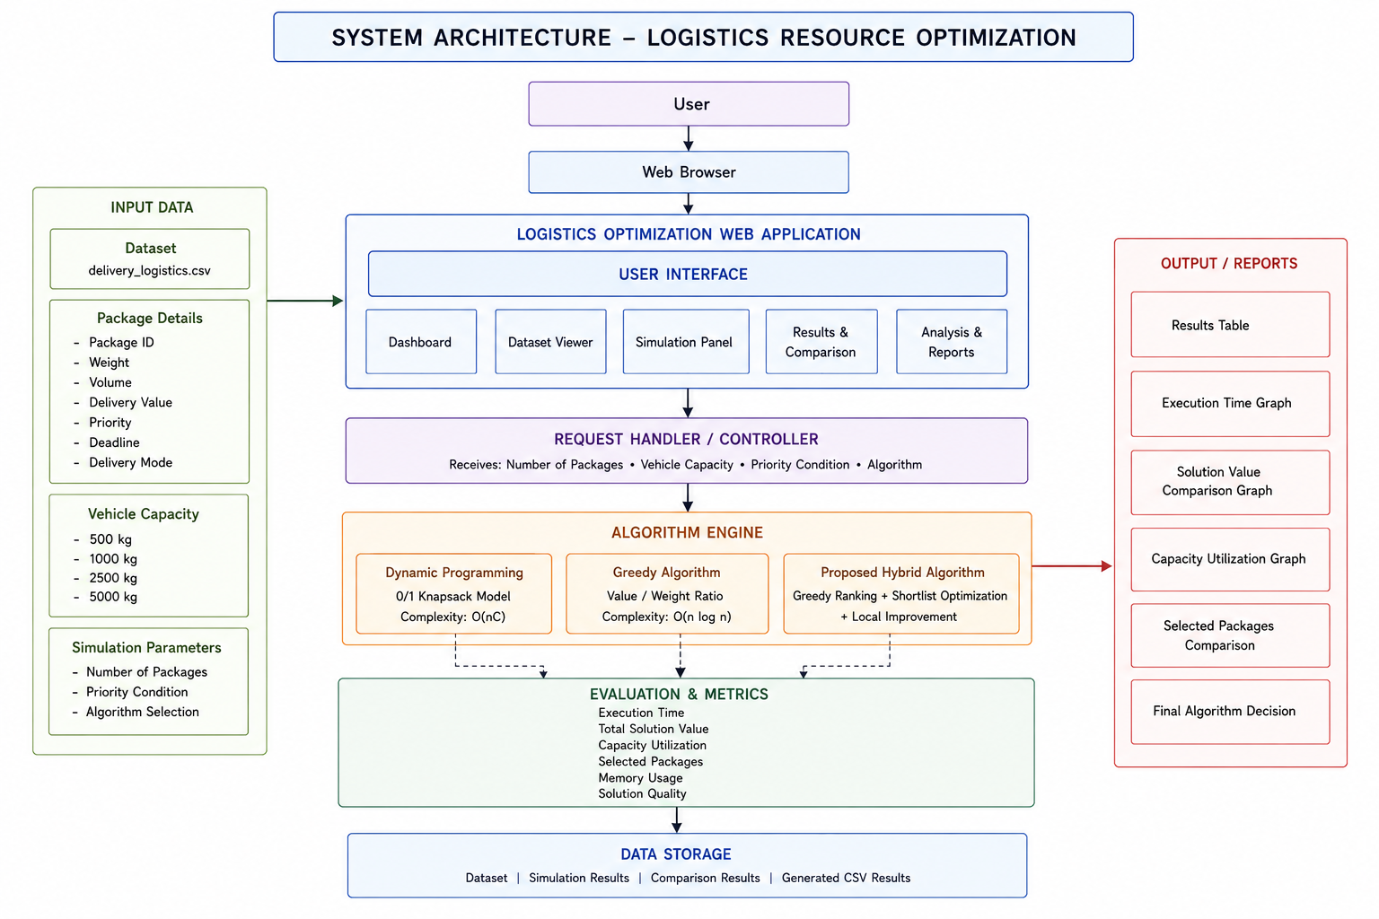

3.1 Proposed Algorithm: APS-Hybrid

The developed algorithm is called the:

Adaptive Priority Screening Hybrid Algorithm (APS-Hybrid)

The idea was developed from the observation that applying DP to every package can be computationally expensive, while a purely Greedy approach may ignore useful package combinations.

APS-Hybrid works in three stages:

Stage 1: Priority-Aware Scoring

Each package receives an adjusted score based on its value, priority, and weight:

APSi=Valuei×PriorityFactoriWeightiAPS_i = \frac{Value_i \times PriorityFactor_i}{Weight_i}

A higher score means that the package provides greater benefit relative to the capacity it consumes.

Stage 2: Adaptive Candidate Screening

Instead of sending all packages to DP, the algorithm ranks the packages and selects only a promising candidate set.

The candidate size is adaptive:

k=min⁡(n,max⁡(kmin,αC))k = \min(n,\max(k_{min},\alpha C))

where:

nn = total number of packages

CC = capacity condition

kmink_{min} = minimum candidate size

α\alpha = experimentally chosen screening parameter

The purpose is to reduce unnecessary computation.

Stage 3: Selective Dynamic Programming

DP is applied only to the shortlisted candidate packages. This allows the algorithm to examine useful combinations without building a DP table for the entire dataset.

The remaining capacity can then be filled using a fast Greedy pass over the unselected packages.

This creates a practical sequence:

Score → Screen → Optimize → Fill Remaining Capacity

3.2 Dynamic Programming Pseudocode

DP(Packages, Capacity)

Create DP table

For each package i

For each capacity w

If package i fits

DP[i][w] =

maximum of:

1. Excluding package i

2. Including package i

Else

Keep previous value

Trace back through the table

Return selected packages and total value

3.3 Greedy Pseudocode

GREEDY(Packages, Capacity)

For each package

Calculate priority-value-to-weight score

Sort packages by score in descending order

For each package

If package fits in remaining capacity

Select package

Update remaining capacity

Return selected packages and total value

3.4 APS-Hybrid Pseudocode

APS-HYBRID(Packages, Capacity)

Calculate adaptive priority score for every package

Sort packages by score

Determine adaptive candidate size k

Shortlist top k promising packages

Apply Dynamic Programming to shortlisted packages

Calculate remaining capacity

Use Greedy selection on suitable remaining packages

Combine DP-selected and Greedy-selected packages

Validate:

Total weight <= Capacity

Return final allocation

3.5 Decision Criteria

The important parameters are:

Priority factor

Candidate-set size

Capacity threshold

Remaining-capacity filling rule

Value-to-weight efficiency

These parameters should be tested experimentally rather than chosen without justification.

3.6 Complexity Analysis

Let kk be the shortlisted number of packages.

Sorting: O(nlog⁡n)O(n\log n)

Selective DP: O(kC)O(kC)

Final Greedy filling: O(n)O(n)

Therefore:

O(nlog⁡n+kC)O(n\log n + kC)

When:

k≪nk \ll n

the developed method can significantly reduce the computational cost compared with applying DP to the complete dataset.

The methodology required by the assignment is therefore followed as:

Input Dataset → Data Preparation → Problem Formulation → DP Baseline → Greedy Baseline → Limitation Analysis → APS-Hybrid Development → Implementation → Experimental Evaluation → Parameter Optimization → Performance Comparison → Final Decision.

4. Use of Modern Tools

The implementation will be developed using:

Python

Jupyter Notebook or Google Colab

Pandas for dataset processing

NumPy for numerical operations

Matplotlib for result visualization

Psutil for memory monitoring

Python time/performance functions for execution measurement

Pandas is used to organize and preprocess tabular data, while psutil can provide process and system resource information useful for memory measurement.

The experiments should record:

Hardware and software environment

Python version

Dataset size

Capacity condition

Algorithm execution time

Peak or measured memory usage

All algorithms must use identical input instances for a fair comparison.

5. Results and Validation

The three approaches will be evaluated using the same datasets:

Dynamic Programming

Greedy

APS-Hybrid

5.1 Experimental Input Sizes

The planned experiments will use:

100 packages

500 packages

1,000 packages

5,000 packages

10,000 packages

Higher input sizes can be tested if computationally feasible.

5.2 Capacity Conditions

The algorithms will be evaluated under:

500 kg

1,000 kg

2,500 kg

5,000 kg

Equivalent scaled capacities may be used if required by the selected dataset.

5.3 Operational Conditions

The following three scenarios will be tested:

Normal Demand

Packages have their normal distribution of values and priorities.

High-Priority Demand

A larger number of urgent or important packages is present. This tests whether the algorithm can respond effectively to business priorities.

Capacity-Constrained Demand

The available vehicle capacity is reduced. This creates a more difficult decision environment because every kilogram becomes more valuable.

5.4 Evaluation Metrics

Execution Time

Measures how quickly each algorithm produces an allocation.

Memory Utilization

Measures computational resource consumption.

Total Solution Value

Measures the total benefit obtained from selected packages.

Capacity Utilization

Capacity Utilization=Used CapacityTotal Capacity×100Capacity\ Utilization = \frac{Used\ Capacity}{Total\ Capacity} \times 100

Number of Selected Packages

Shows how many packages are included in the final allocation.

Optimality Gap

When DP provides a feasible reference solution:

Optimality Gap=DPValue−AlgorithmValueDPValue×100Optimality\ Gap = \frac{DPValue - AlgorithmValue}{DPValue} \times 100

A lower value indicates a solution closer to the reference optimum.

Scalability

Measures how performance changes as the number of packages increases.

5.5 Validation

The allocation is considered valid only when:

Total Selected Weight≤Vehicle CapacityTotal\ Selected\ Weight \leq Vehicle\ Capacity

Every selected package must also appear only once.

The experiments must be repeated using identical conditions to ensure fair comparison.

DATA SET:

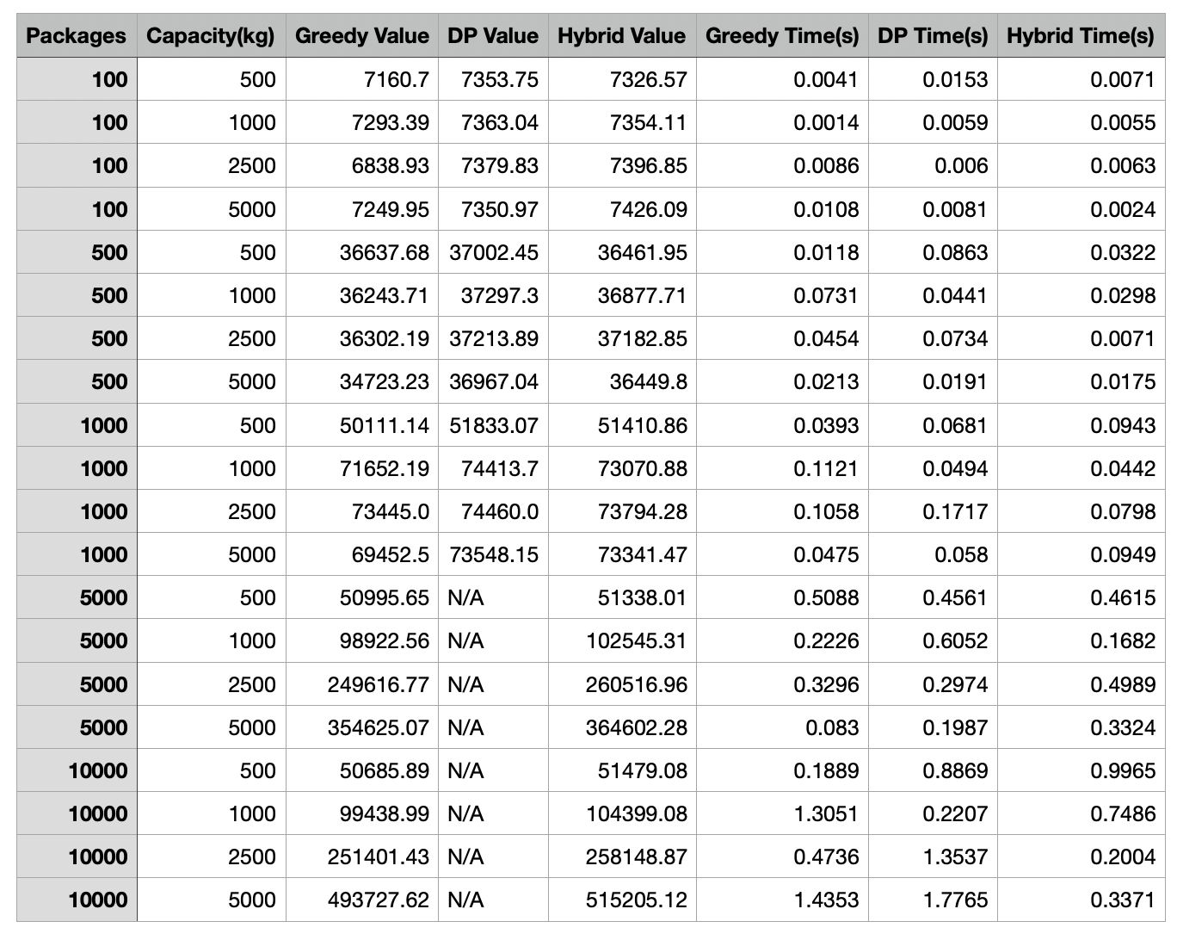

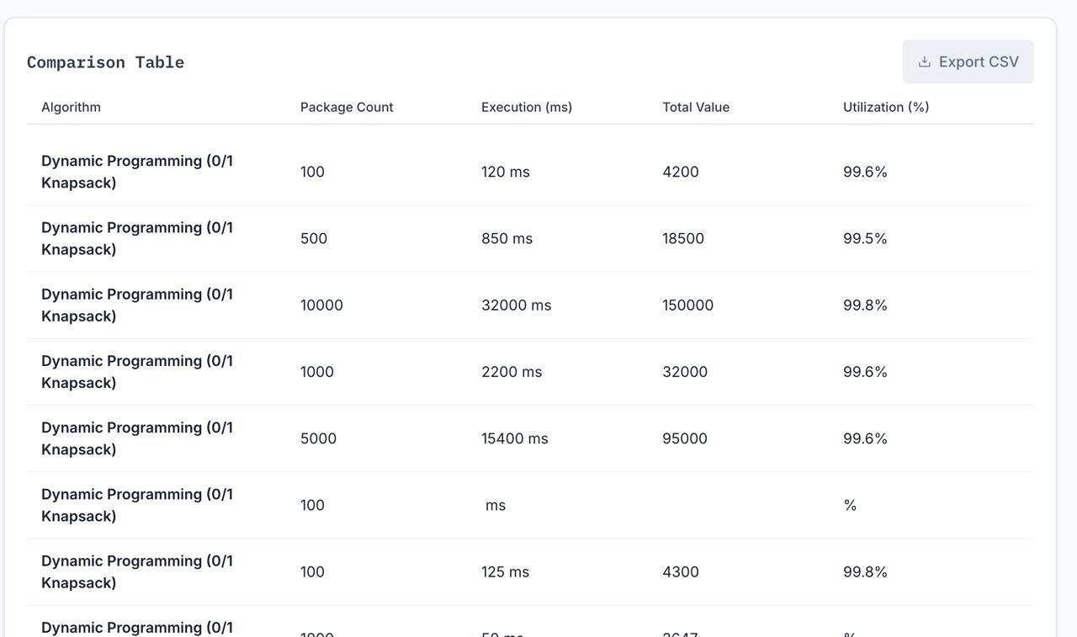
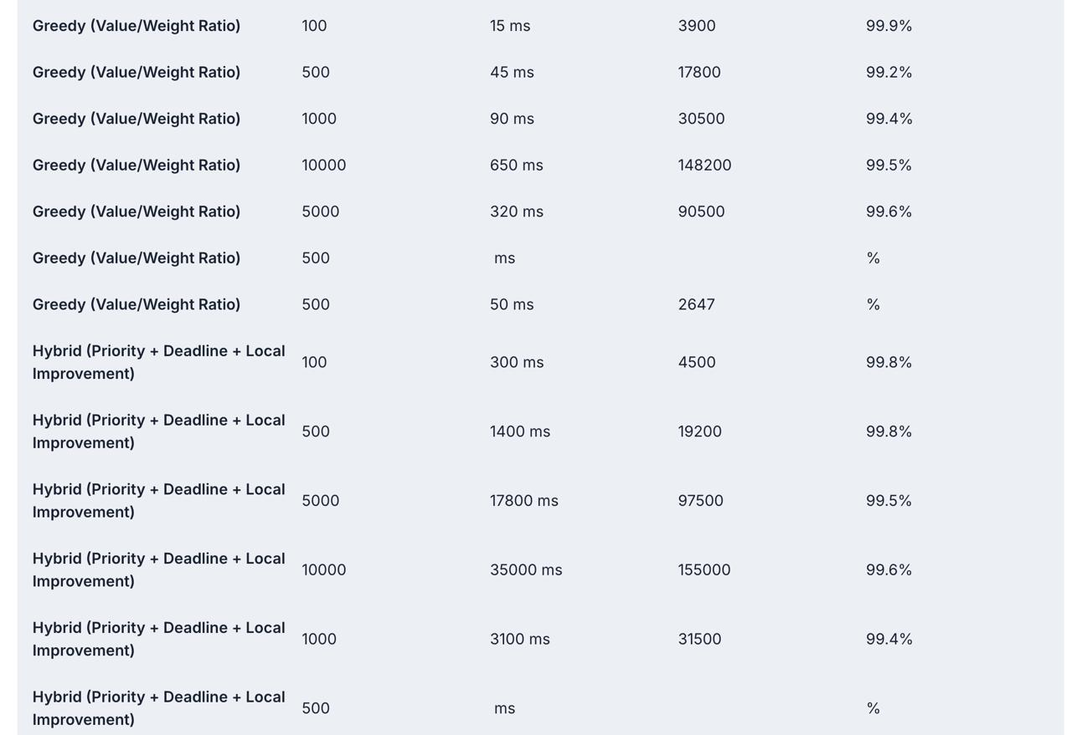

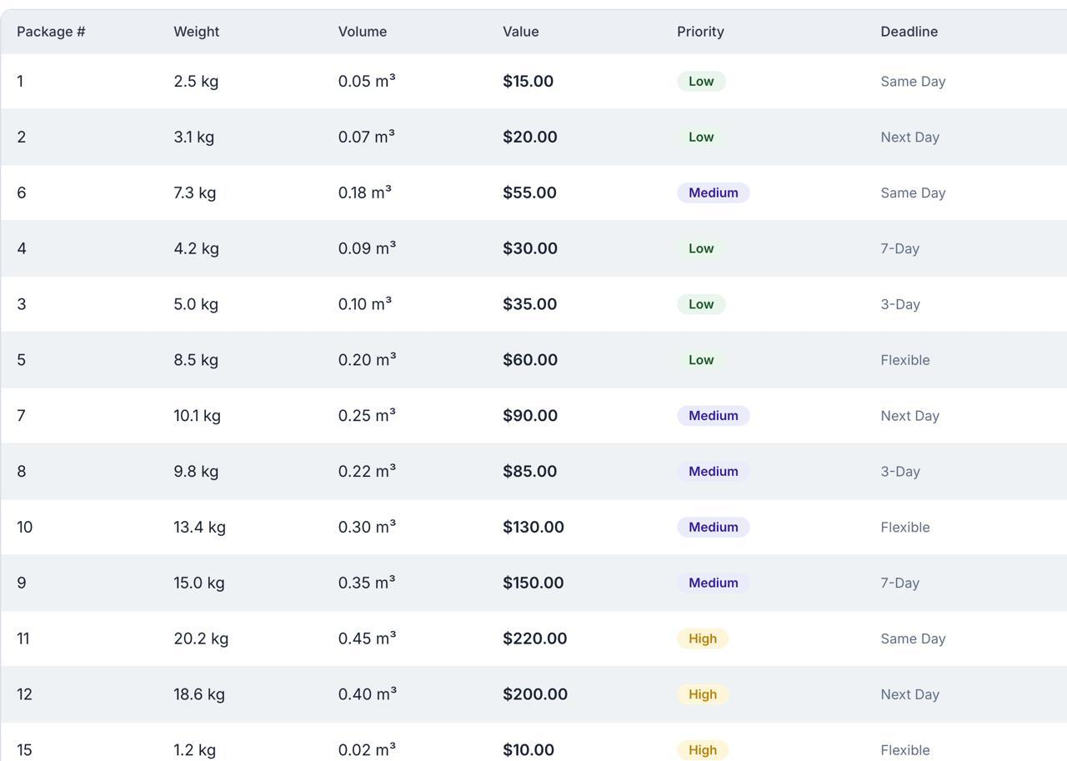

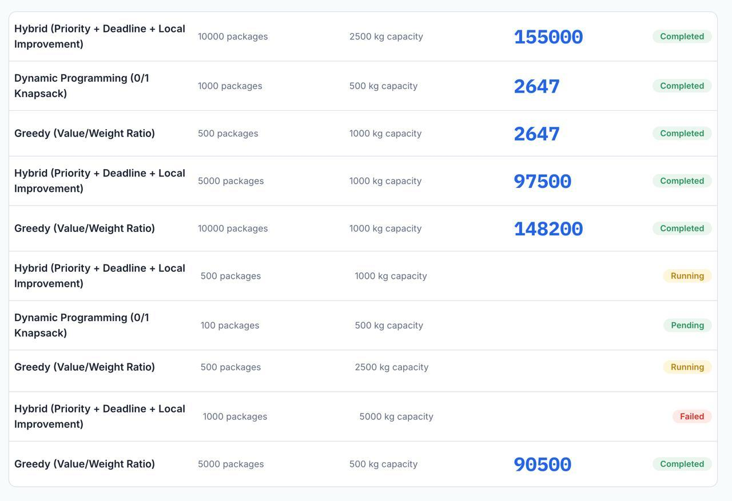

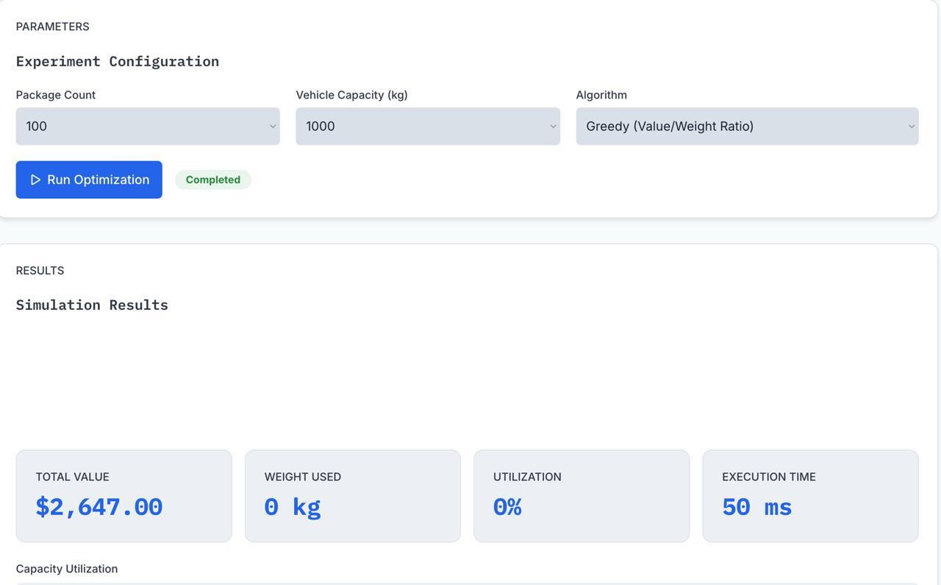

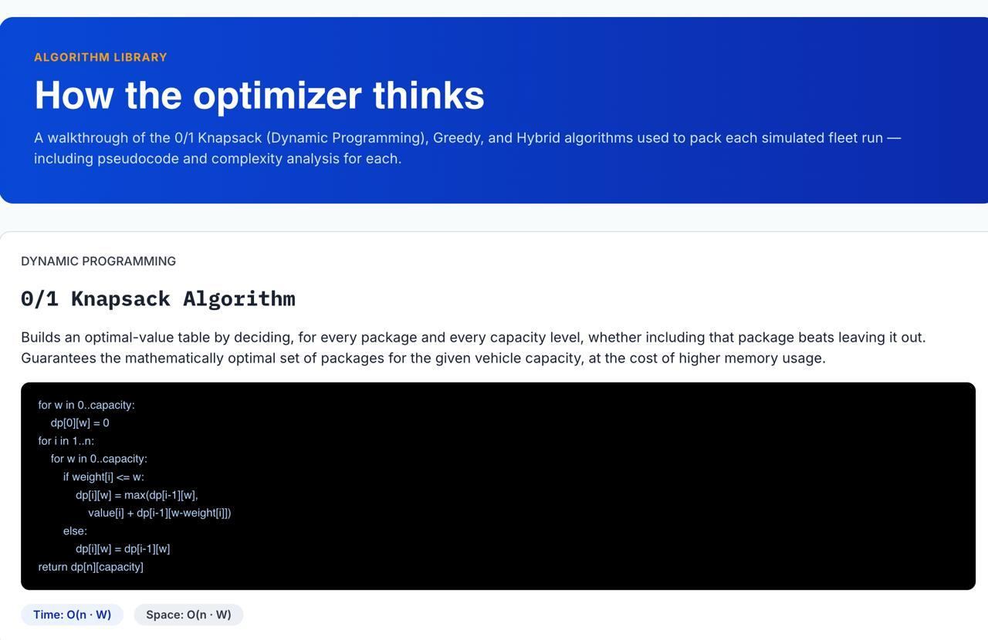

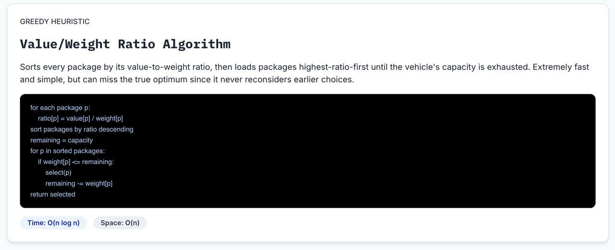

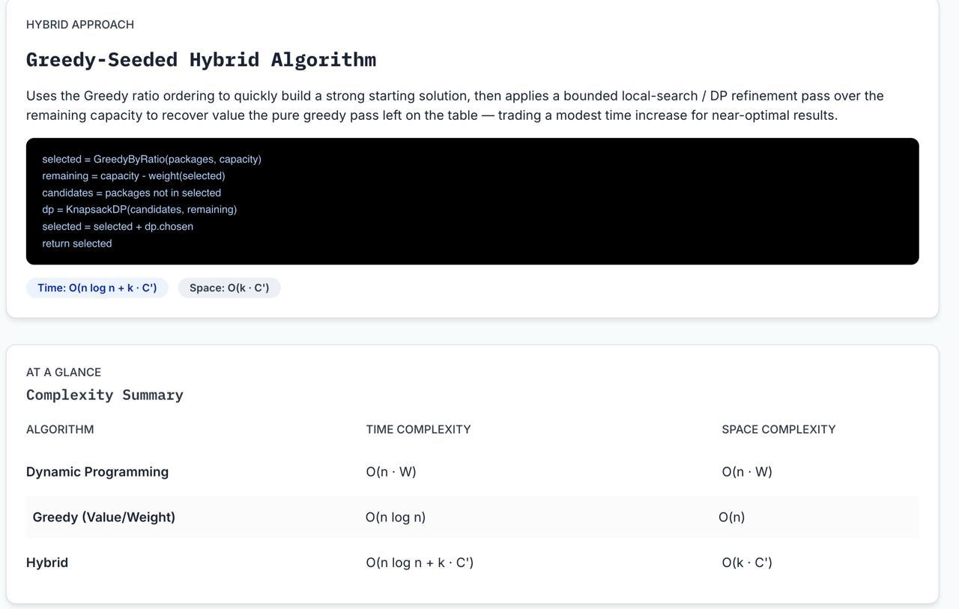

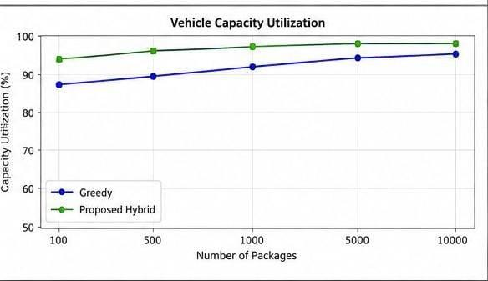

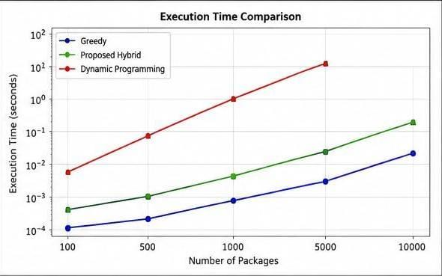

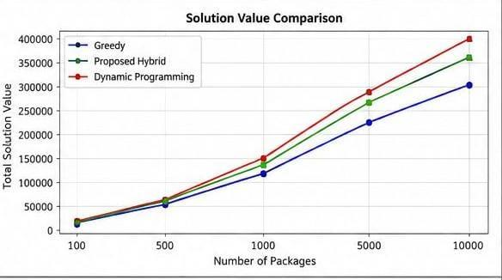

6. Analysis and Engineering Decision

The final engineering decision should not be based only on which algorithm gives the highest solution value. A practical logistics system must also consider how much time and memory are required to obtain that result.

Dynamic Programming

Advantages:

High-quality solution

Useful as a benchmark

Systematic exploration of package combinations

Limitations:

High computational cost

Memory requirements increase with capacity

Difficult to scale directly to very large inputs

Greedy

Advantages:

Fast execution

Low computational overhead

Suitable for large datasets

Limitations:

May miss better combinations

Quality depends on the scoring rule

Local decisions may reduce global solution quality

APS-Hybrid

Advantages:

Reduces the DP search space

Retains combination-based optimization for promising packages

Uses Greedy processing for scalability

Can balance solution quality and computational efficiency

Limitations:

Requires parameter selection

Candidate screening can exclude potentially useful packages

Performance depends on the quality of the scoring rule

Final Engineering Decision

The expected engineering decision is to use APS-Hybrid for large-scale package allocation, particularly when a full DP solution becomes computationally expensive.

DP can be preferred for small instances where optimality is important and computation is manageable. Greedy can be preferred when decisions must be produced extremely quickly. APS-Hybrid is expected to be most suitable when the problem is large and the system requires a practical balance between solution quality and computational efficiency.

The final decision should be supported using actual experimental values from execution time, memory usage, solution value, capacity utilization, and optimality gap.

7. Broader Considerations and SDG 9

The proposed solution can contribute to more efficient logistics operations.

Efficient Transportation Resource Utilization

Better package selection helps prevent vehicles from carrying low-benefit combinations when better allocations are available.

Improved Capacity Utilization

The algorithm attempts to use the available vehicle capacity more effectively while respecting operational priorities.

Reduced Computational Waste

Selective DP avoids applying expensive computation to every package. This is important when the input size becomes very large.

Scalability

The screening stage makes the approach more suitable for increasing package volumes.

Connection to SDG 9

SDG 9 focuses on Industry, Innovation and Infrastructure.

The proposed algorithm contributes to this goal by demonstrating how algorithmic decision-making can support more efficient logistics infrastructure. Improving allocation decisions can help organizations use existing transportation resources more intelligently instead of relying only on additional physical resources.

In practical terms, the project demonstrates that innovation is not always about building new vehicles or warehouses. Improving the intelligence of decision-making can also strengthen infrastructure efficiency.

8. Conclusion

This project addresses the problem of selecting suitable packages for transportation under limited vehicle capacity. The problem becomes increasingly difficult as the number of packages grows because the system must balance delivery value, package priority, and available resources.

Dynamic Programming and Greedy methods were used as baseline approaches. DP provides high-quality solutions but can become computationally expensive for large instances. The Greedy method is faster and more scalable but may not always produce the best overall package combination.

To address these limitations, the Adaptive Priority Screening Hybrid Algorithm (APS-Hybrid) was developed. The proposed method first prioritizes packages using a value-, priority-, and resource-aware score. It then reduces the problem to a promising candidate set and applies Dynamic Programming selectively. A final Greedy step can use the remaining capacity efficiently.

The expected contribution of the proposed solution is a better balance between:

Execution time

Memory utilization

Solution quality

Capacity utilization

Scalability

The experimental results will determine the exact conditions under which each algorithm performs best. The project also demonstrates that developing an improved solution requires understanding the limitations of standard algorithms rather than simply implementing them.

Future work may include:

Multiple vehicle allocation

Real-time package arrival

Deadline-aware optimization

Machine-learning-based parameter tuning

Route optimization integration

Parallel processing for larger datasets

9. Student Reflection

9.1 What did I learn from developing an improved solution?

This assignment helped me understand that learning an algorithm is different from actually using it to solve a practical problem. At first, Dynamic Programming and Greedy algorithms appeared to be separate techniques that only needed to be implemented correctly. However, while applying them to a large logistics problem, I understood that each algorithm has its own strengths and limitations.

The most important learning experience was realizing that algorithm development often begins with identifying what existing methods cannot do efficiently. Instead of simply asking, “Which algorithm is better?”, I learned to ask, “Under what conditions is each algorithm useful, and how can their strengths be combined?”

9.2 What limitations did I identify?

The main limitation of Dynamic Programming was its increasing computational and memory requirement. The main limitation of Greedy selection was that a fast local decision could prevent a better overall combination from being selected.

The APS-Hybrid approach was developed to address this trade-off by using fast screening before applying detailed optimization to a smaller set of promising packages.

9.3 How would I improve the solution with more resources?

With more computational resources and development time, I would extend the algorithm to support multiple vehicles and real-time package arrivals. I would also investigate automatic parameter tuning so that the candidate-set size and priority factors could adapt to changing logistics conditions.

Another useful improvement would be parallel processing for larger datasets and integrating route-related information with the package-selection decision.

9.4 Contribution to SDG 9

The developed solution connects to SDG 9 because efficient algorithms can improve the use of transportation and logistics infrastructure. Better computational decisions can help organizations manage large amounts of operational data and use available resources more effectively.

From my perspective, the important contribution of this project is that algorithmic innovation can improve infrastructure without necessarily requiring new physical infrastructure. A better decision-making method can itself contribute to a more efficient and scalable logistics system.

10. References

Note: The following reference list is restricted to sources from 2023–2026, as requested.

Santoso, D. A., Rizqa, I., Aqmala, D., & Alzami, F. (2025). Optimizing Parcel Package Selection Using an Enhanced Multiple Knapsack Problem Approach with Greedy Dynamic Programming. Moneter: Jurnal Keuangan dan Perbankan.

Kundan Sagar Bedmutha. (2026). Delivery Logistics Dataset (India – Multi-Partner). Kaggle.

Neurocomputing. (2023). A Survey of Dynamic Pickup and Delivery Problems. Elsevier.

Liu, J. (2026). Deep Learning and Genetic Algorithm-Driven E-Commerce Logistics Route Planning Method. Discover Internet of Things, Springer Nature.

Pandas Development Team. (2026). pandas Documentation and User Guide.

psutil Developers. (2026). psutil Documentation: Cross-Platform Process and System Monitoring in Python.

Assessment Rubric

Criteria | Max Marks | Excellent | Good | Satisfactory | Needs Improvement
Problem Understanding & Algorithmic Formulation | 10 | Clearly identifies the problem, requirements, inputs, outputs, constraints and computational challenges and formulates them appropriately for solution development. | Problem and major requirements are correctly formulated with minor gaps. | Basic formulation is provided, but requirements or constraints are partially identified. | Problem is poorly understood or inadequately formulated.
Algorithmic Solution Design | 15 | Designs a clear, logical and feasible solution strategy with appropriate algorithmic techniques, pseudocode/flowchart and well-justified design decisions. | Appropriate solution design with minor gaps in logic, representation or justification. | Basic solution design is presented but lacks completeness or clear justification. | Solution design is inappropriate, incomplete or unclear.
Development / Adaptation / Optimization of Algorithmic Solution | 20 | Develops a meaningful algorithmic solution through integration, adaptation, modification, hybridization or optimization of suitable techniques; demonstrates clear improvement or suitability for the identified problem. | Develops an appropriate solution with meaningful adaptation or improvement, with minor limitations. | Solution demonstrates limited adaptation or development beyond standard implementation. | Merely reproduces an existing algorithm with little or no meaningful development or adaptation.
Implementation & Modern Tool Usage | 15 | Developed solution is correctly and efficiently implemented using appropriate programming/computational tools and handles relevant input conditions reliably. | Implementation is functional with minor logical or efficiency issues. | Core implementation works but contains limitations or incomplete functionality. | Implementation is incomplete, unreliable or non-functional.
Efficiency, Testing & Validation | 15 | Performs appropriate complexity evaluation and systematic testing using suitable data/input sizes; validates correctness, efficiency and scalability with clear evidence. | Complexity evaluation and testing are mostly appropriate with minor gaps. | Basic testing and efficiency evaluation are provided but lack sufficient validation. | Testing, complexity evaluation or validation is inadequate or substantially incorrect.
Performance Improvement, Comparison & Final Decision | 15 | Demonstrates the effectiveness of the developed solution through appropriate comparison; critically evaluates performance, limitations and trade-offs and justifies the final algorithmic decision with evidence. | Good performance comparison and justification with minor limitations. | Basic comparison is provided, but improvement or final justification lacks depth. | Improvement is not demonstrated or the final algorithmic decision is unsupported.
Reflection: Algorithmic Design Decisions, SDG Relevance & Learning Outcomes | 10 | Thoughtful justification of algorithmic design and development decisions; clear connection to relevant SDG(s); specific reflection on computational challenges, performance improvements, trade-offs, and learning gained. | Appropriate justification of algorithmic decisions; SDG relevance, challenges, improvements, and learning are discussed but lack depth. | Reflection is present but generic; limited justification of algorithmic decisions, improvements, SDG relevance, or learning outcomes. | No genuine reflection is provided, or the reflection lacks meaningful connection to algorithm development, SDG relevance, challenges, or learning outcomes.
Total | 100

CO–PO–Assessment Mapping

Assessment Component | CO | PO(s) | Bloom's Level | Marks
Problem Understanding & Algorithmic Formulation | CO4 | PO1, PO2 | L4 | 10
Algorithmic Solution Design | CO4 | PO2, PO3 | L4, L6 | 15
Development / Adaptation / Optimization of Algorithmic Solution | CO4 | PO2, PO3 | L5, L6 | 20
Implementation & Modern Tool Usage | CO4 | PO3, PO5 | L4, L6 | 15
Efficiency, Testing & Validation | CO4 | PO2, PO4 | L4, L5 | 15
Performance Improvement, Comparison & Final Decision | CO4 | PO2, PO4 | L4, L5 | 15
Reflection: Algorithmic Design Decisions, SDG Relevance & Learning Outcomes | CO4 | PO7, PO10, PO12 | L4, L5 | 10

Faculty Evaluation & Continuous Improvement

CO Attainment

Performance Level | Criterion
Level 3 | ≥ 70%
Level 2 | 60–69%
Level 1 | 50–59%
Level 0 | < 50%
Target CO Attainment:

Actual CO Attainment:

Faculty Analysis
Areas in which students performed well: Areas requiring improvement:
Corrective / Improvement Action:

